**Example 1**

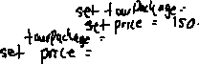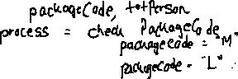

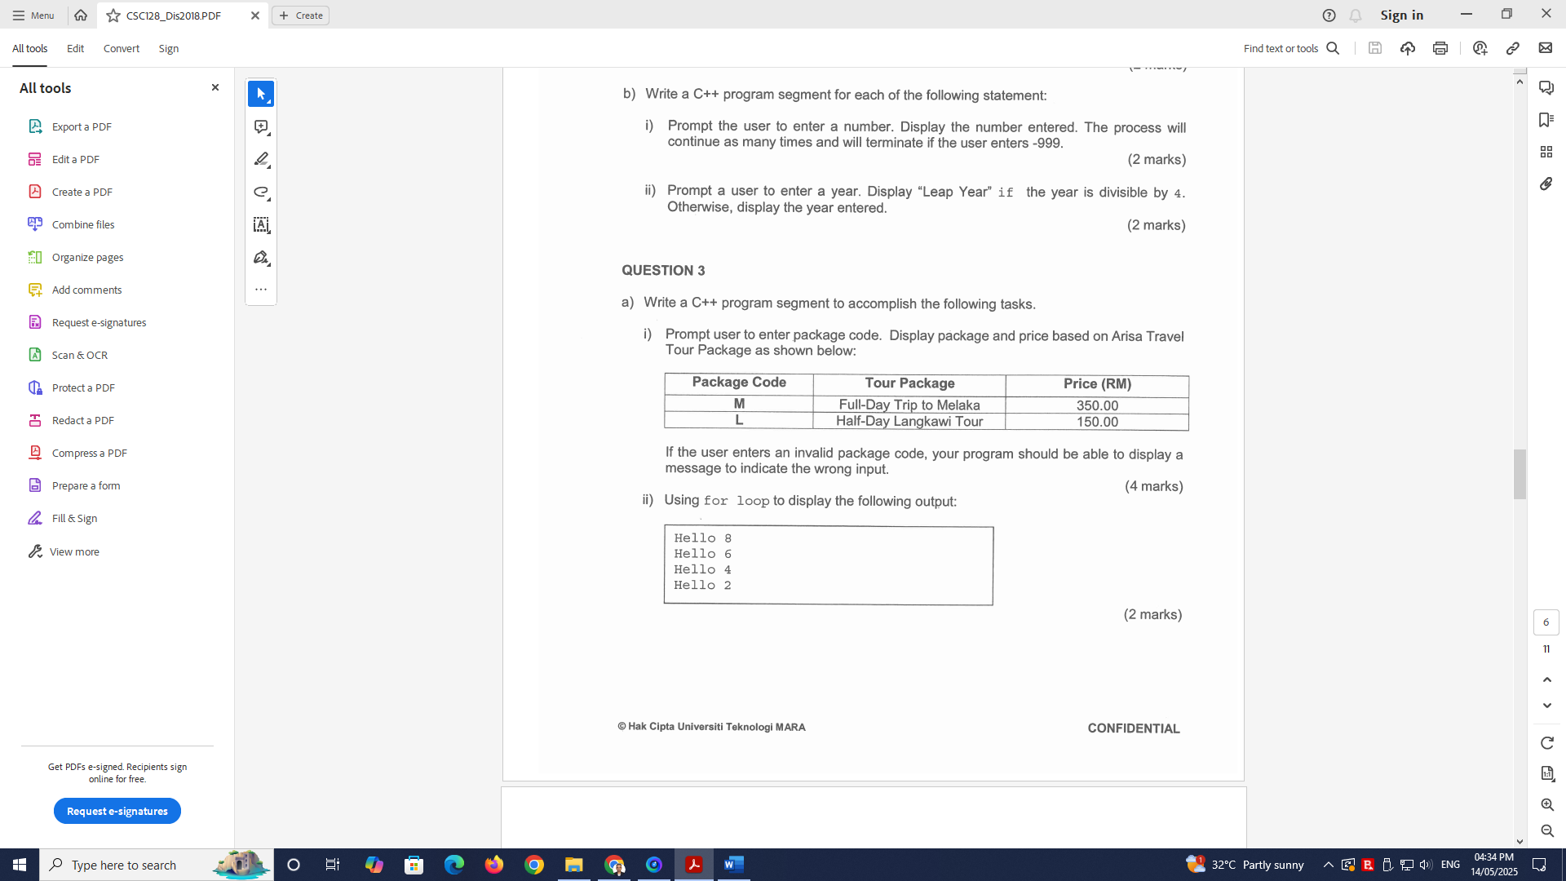

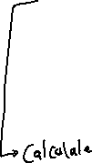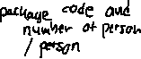

**IPO**



Flowchart :

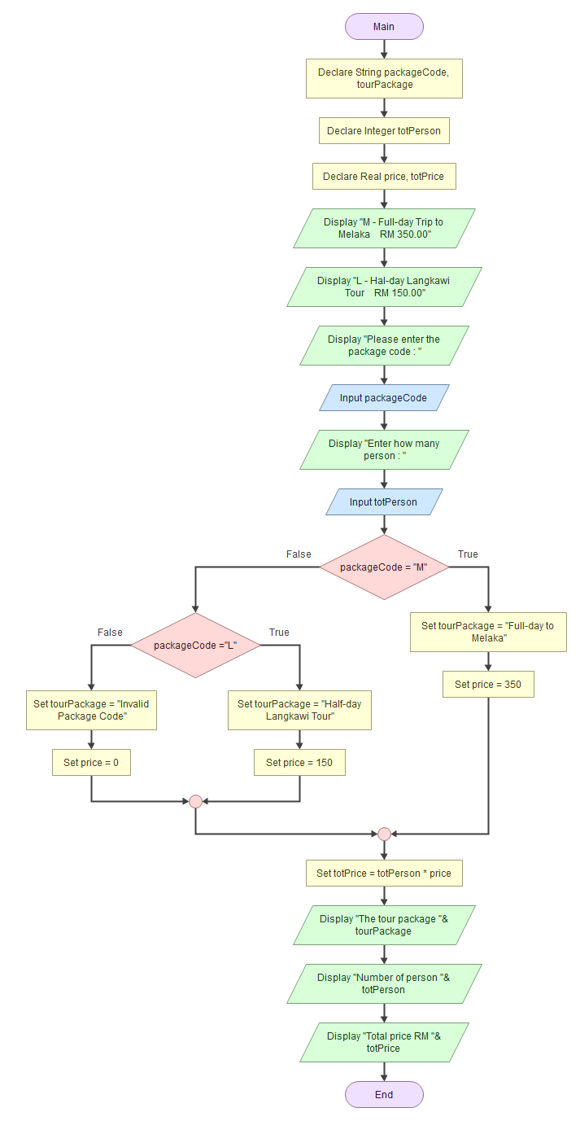

**Pseudocode**

Start

Declare String packageCode, tourPackage

Declare Integer totPerson

Declare Real price, totPrice

Prompt "M - Full-day Trip to Melaka RM 350.00"

Prompt "L - Hal-day Langkawi Tour RM 150.00"

Prompt "Please enter the package code : "

Read packageCode

Prompt "Enter how many person : "

read totPerson

If packageCode = "M"

Set tourPackage = "Full-day to Melaka"

Assign price = 350

Else

If packageCode ="L"

Assign tourPackage = "Half-day Langkawi Tour"

Assign price = 150

Else

Assign tourPackage = "Invalid Package Code"

Assign price = 0

End

End

Assign totPrice = totPerson * price

Display "The tour package "&tourPackage

Display "Number of person "&totPerson

Display "Total price RM "&totPrice

End

Sample of output :

Sample 1:

M - Full-day Trip to Melaka RM 350.00

L - Hal-day Langkawi Tour RM 150.00

Please enter the package code :

M

Enter how many person :

10

The tour package Full-day to Melaka

Number of person 10

Total price RM 3500

Sample 2:

M - Full-day Trip to Melaka RM 350.00

L - Hal-day Langkawi Tour RM 150.00

Please enter the package code :

L

Enter how many person :

10

The tour package Half-day Langkawi Tour

Number of person 10

Total price RM 1500

Sample 3:

M - Full-day Trip to Melaka RM 350.00

L - Hal-day Langkawi Tour RM 150.00

Please enter the package code :

P

Enter how many person :

10

The tour package Invalid Package Code

Number of person 10

Total price RM 0

Second Answer

Input: packageCode

Process : check packageCode :

packageCode ‘M’ : set tourPackage = “Full-day Trip to Melaka”

set price = 350

packageCode ‘L’ : set tourPackage =”Half-day Langwaki Tour”

set price = 150

Output : tourPackage and price

**Flowchart**

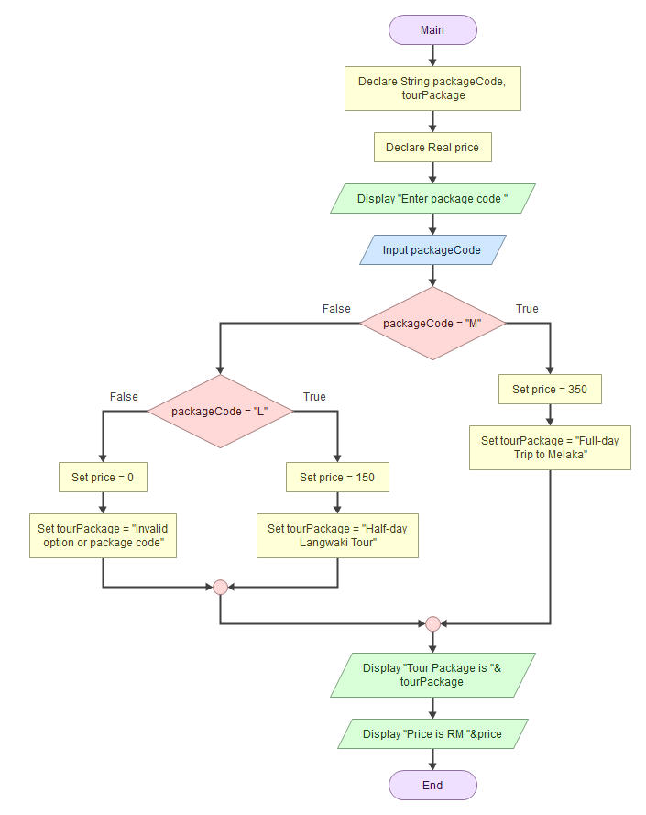

Pseudocode

Start

Declare String packageCode, tourPackage

Declare Real price

prompt "Enter package code "

read packageCode

If packageCode = "M"

assign price = 350

assign tourPackage = "Full-day Trip to Melaka"

Else

If packageCode = "L"

Assign price = 150

Assign tourPackage = "Half-day Langwaki Tour"

Else

Assign price = 0

Assign tourPackage = "Invalid option or package code"

End

End

display "Tour Package is "&tourPackage

display "Price is RM "&price

End

Sample of output:

Enter package code

M

Tour Package is Full-day Trip to Melaka

Price is RM 350

Enter package code

P

Tour Package is Invalid option or package code

Price is RM 0

*Notes : Example 9*

**Example 2**

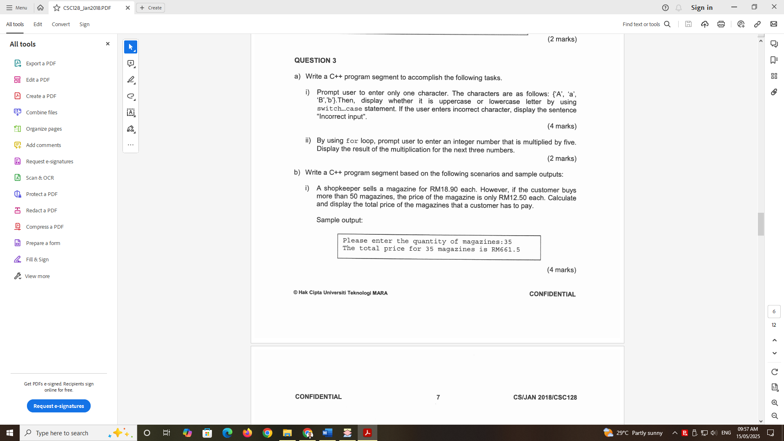

**IPO :**

Input:

quanMagazine

Process:

If (quanMagazine >= 50) , set price_per_unit is RM12.50

Else set price_per_unit is RM18.90

Calculate the totalPrice = quanMagazine * price_per_unit

Output:

Display the totalPrice

**Flowchart**

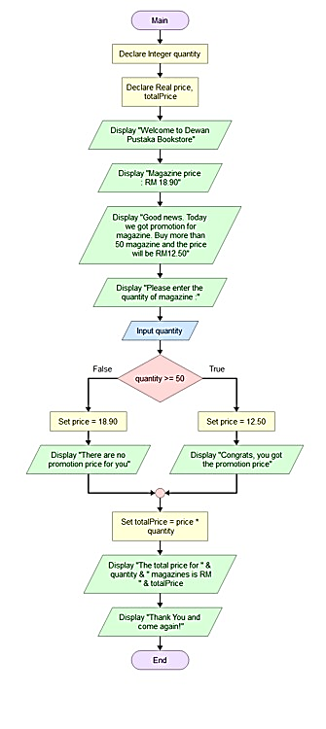

**Pseudocode :**

Start

Declare Integer quantity

Declare Real price, totalPrice

Display "Welcome to Dewan Pustaka Bookstore"

Display "Magazine price : RM 18.90"

Display "Good news. Today we got promotion for magazine. Buy more than 50 magazine and

the price will be RM12.50"

prompt "Please enter the quantity of magazine :"

read quantity

If quantity >= 50 Then

Set price = 12.5

Display "Congrats, you got the promotion price"

Else

Set price = 18.9

Display "There are no promotion price for you"

End If

calculate totalPrice = price * quantity

Display "The total price for ", quantity, " magazines is RM ", totalPrice

Display "Thank You and come again!"

End

**Sample output :**

First Sample

Welcome to Dewan Pustaka Bookstore

Magazine price : RM 18.90

Good news. Today we got promotion for magazine. Buy more than 50 magazine and the price will be RM12.50

Please enter the quantity of magazine :

50

Congrats, you got the promotion price

The total price for 50 magazines is RM 625

Thank You and come again!

Second Sample

Welcome to Dewan Pustaka Bookstore

Magazine price : RM 18.90

Good news. Today we got promotion for magazine. Buy more than 50 magazine and the price will be RM12.50

Please enter the quantity of magazine :

10

There are no promotion price for you

The total price for 10 magazines is RM 189

Thank You and come again!

**Second Answer :**

**IPO:**

Input : totMagazines

Proses : check totMagazines

Calculate totalPrice

totMagazines > 50 : calculate totalPrice = totMagazines * 12.50

totMagazines <= 50 : calculate totalPrice = totMagazines * 18.90

Output : totMagazines and totalPrice

**Flowchart:**

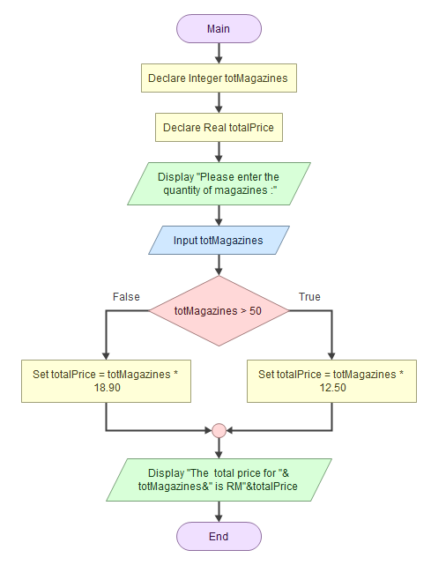

**Pseudocode:**

Start

Declare Integer totMagazines

Declare Real totalPrice

Prompt "Please enter the quantity of magazines :"

Read totMagazines

If totMagazines > 50

Assign totalPrice = totMagazines * 12.50

Else

Assign totalPrice = totMagazines * 18.90

End

Display "The total price for "&totMagazines&" is RM"&totalPrice

End

**Sample of Output :**

Please enter the quantity of magazines :

100

The total price for 100 is RM1250

Please enter the quantity of magazines :

10

The total price for 10 is RM189

*Notes : Example 10*

**Example 3:**

Write a program to calculate the total price of textbook (s) that the user has to pay to ABC University Bookstore. The prices of textbook are shown in the following table:

|  |  |  |  |
| --- | --- | --- | --- |
| **TEXT BOOK Code** | **TYPE** | **Price Per Textbook** | **Discount** |
| C | Civil Textbook | RM 75 | 5% |
| M | Mechanical Textbook | RM 82 | 8% |
| Others | Display error message “Sorry, invalid textbook code.” | | |

The total price is calculated based on the textbook’s code and number of textbook(s) that the user has entered. The program will display an error message if the data entered by user is invalid.

The sample program output is as below:

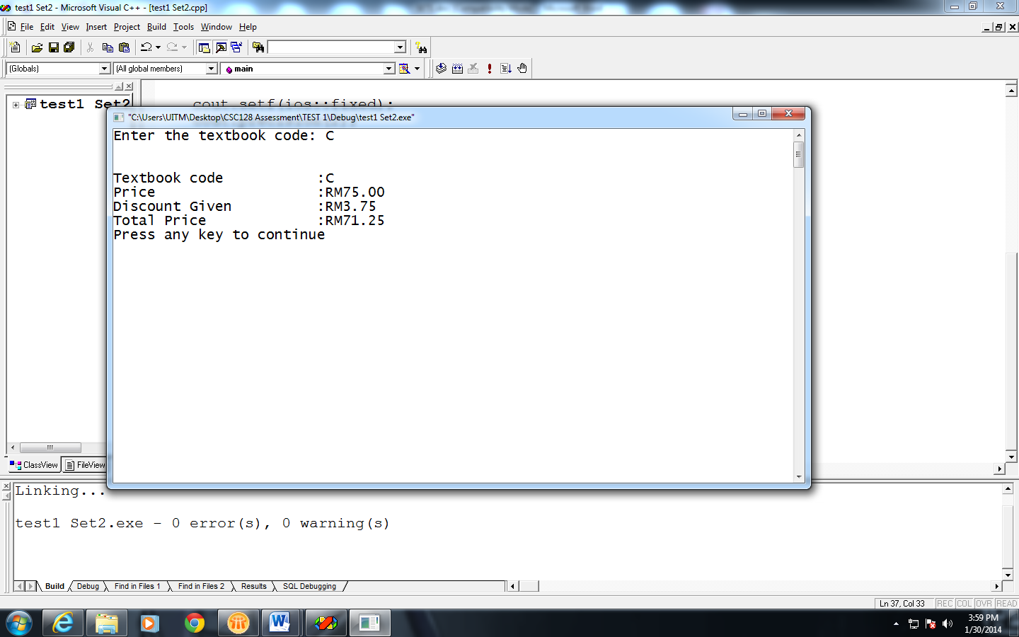

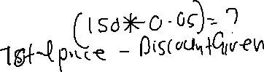

**IPO:**

Input : code, numOfTextBook

Process : check code:

Code = “C” : set price = 75.00



Set discount = 0.05



Set bookName = “Civil Textbook”

Code = “M” : set price = 82

Set discount = 0.08

Set bookName = “Mechanical Textbook”

Else : set price = 0

Set discount = 0

Set bookName = “Sorry, invalid textbook code.”

Calculate totalPrice = numOfTextBook * price

Calculate totDiscount = totalPrice * discount

Calculate netPrice = totPrice – totDiscount

Output : code, bookName, price, numOfTextBook, totalPrice, discount, totDiscount, netPrice

**Flowchart :**

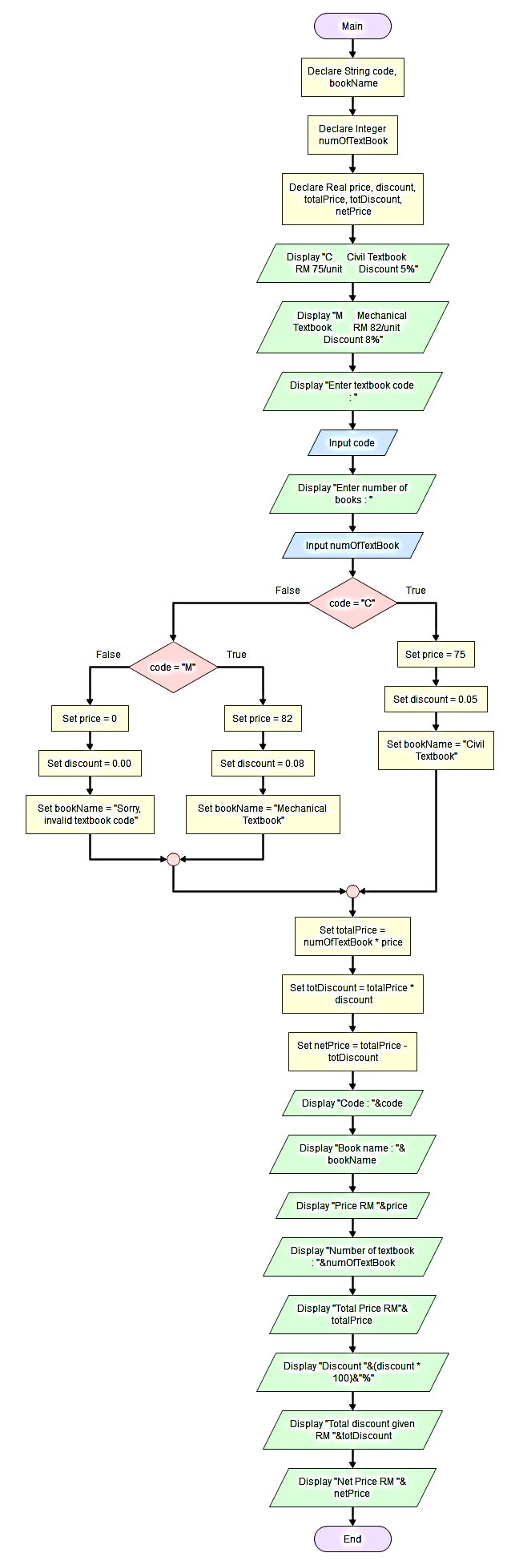

**Pseudocode:**

Start

Declare String code, bookName

Declare Integer numOfTextBook

Declare Real price, discount, totalPrice, totDiscount, netPrice

Display "C Civil Textbook RM 75/unit Discount 5%"

Display "M Mechanical Textbook RM 82/unit Discount 8%"

prompt "Enter textbook code : "

read code

prompt "Enter number of books : "

read numOfTextBook

If code = "C"

Set/assign/initial price = 75

Assign discount = 0.05

Assign bookName = "Civil Textbook"

Else

If code = "M"

Assign price = 82

Assign discount = 0.08

Assign bookName = "Mechanical Textbook"

Else

Assign price = 0

Assign discount = 0.00

Assign bookName = "Sorry, invalid textbook code"

End

End

calculate totalPrice = numOfTextBook * price

calculate totDiscount = totalPrice * discount

calculate netPrice = totalPrice - totDiscount

display "Code : "&code

display "Book name : "&bookName

display "Price RM "&price

display "Number of textbook : "&numOfTextBook

display "Total Price RM"&totalPrice

display "Discount "&(discount * 100)&"%"

display "Total discount given RM "&totDiscount

display "Net Price RM "&netPrice

End

Sample 1

C Civil Textbook RM 75/unit Discount 5%

M Mechanical Textbook RM 82/unit Discount 8%

Enter textbook code :

C

Enter number of books :

10

Code : C

Book name : Civil Textbook

Price RM 75

Number of textbook : 10

Total Price RM750

Discount 5%

Total discount given RM 37.5

Net Price RM 712.5

Sample 2

C Civil Textbook RM 75/unit Discount 5%

M Mechanical Textbook RM 82/unit Discount 8%

Enter textbook code :

M

Enter number of books :

10

Code : M

Book name : Mechanical Textbook

Price RM 82

Number of textbook : 10

Total Price RM820

Discount 8%

Total discount given RM 65.6

Net Price RM 754.4

Sample 3(enter wrong code)

C Civil Textbook RM 75/unit Discount 5%

M Mechanical Textbook RM 82/unit Discount 8%

Enter textbook code :

P

Enter number of books :

10

Code : P

Book name : Sorry, invalid textbook code

Price RM 0

Number of textbook : 10

Total Price RM0

Discount 0%

Total discount given RM 0

Net Price RM 0

*Notes : Example 13*

**Example 4:**

The following table shows the car parking rate according to parking duration.

|  |  |
| --- | --- |
| *Parking duration* | *Parking rate*  *(RM)* |
| First hour (1st hour) | 1.00 |
| The next 3 hours (2nd, 3rd and 4th hours) | 50 cents/hour |
| The next 2 hours (5th and 6th hours) | 40 cents/hour |
| The next 4 hours (7th, 8th, 9th and 10th hours) | 30 cents/hour |

Write a program that obtains the customer name and duration of parking in hour from the user. Assume that the parking duration cannot exceed 10 hours. Display the output as the following format.

++++++++++++++++++++++++++++++++++++++++++++++++++++++

Syarikat Parking Mesra Sdn Bhd

++++++++++++++++++++++++++++++++++++++++++++++++++++++

Customer name :

Duration of parking :

Total charges : RM

==Thank you ==

++++++++++++++++++++++++++++++++++++++++++++++++++++++

**IPO :**

IPO:

Input: parkingDuration, customerName

Process:

If (parkingDuration =1 )

totalCharge = 1

Else if (parkingDuration >= 2 && parkingDuration <= 4)

totalCharge = 1.00 + 0.50 * (parkingDuration – 1)

Else if (parkingDuration >= 5 && parkingDuration <= 6)

totalCharge = 1.00 + 1.50 + 0.40 * (parkingDuration – 4)

Else if (parkingDuration >= 7 && parkingDuration <= 10)

totalCharge = 1.00 + 1.50 + 0.80 + 0.30 * (parkingDuration – 6)

Else

totalCharge = 0

Output: totalCharge

Flowchart :

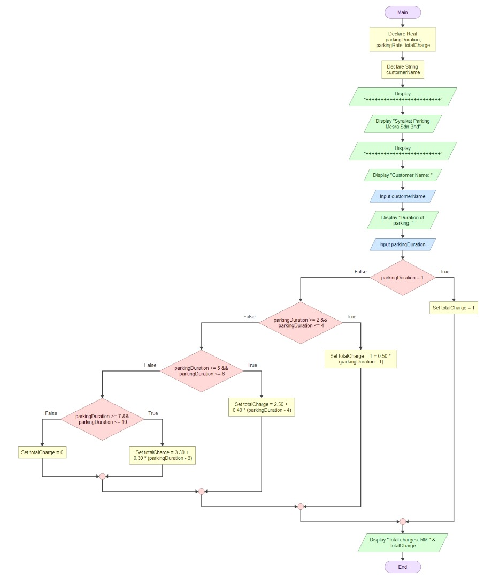

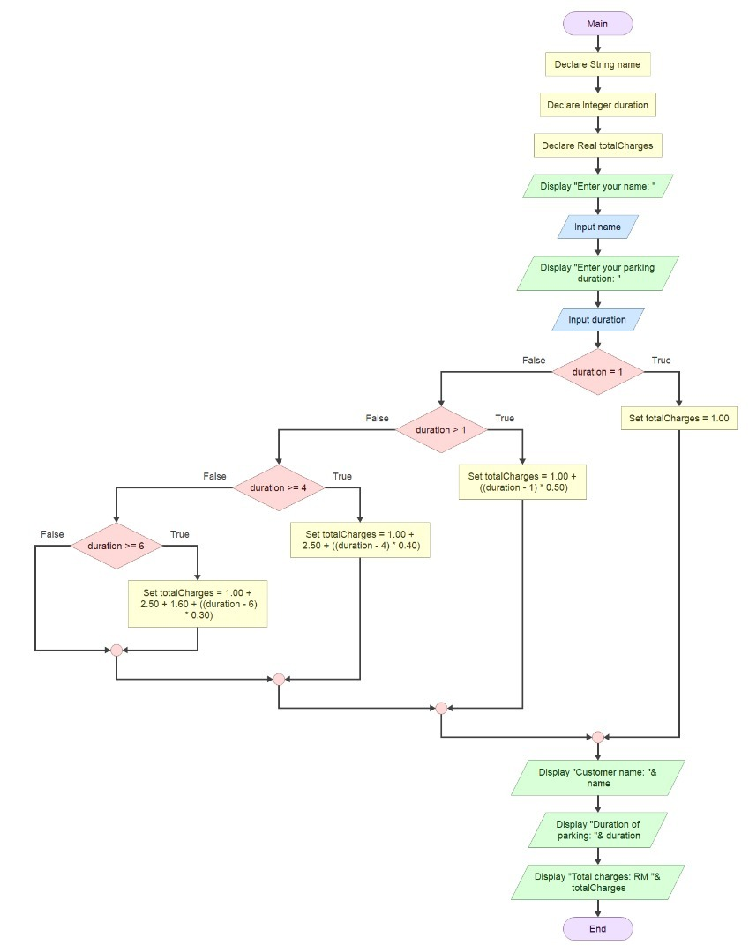



Pseudocode :

Start

Declare String name

Declare Integer duration

Declare Real totalCharges

prompt "Enter your name: "

read name

prompt "Enter your parking duration: "

read duration

If duration == 1 Then

Set totalCharges = 1.0

Else

If duration > 1 Then

calculate totalCharges = 1.0 + (duration – 1) * 0.5

Else

If duration >= 4 Then

calculate totalCharges = 2.5 + (duration – 4) * 0.4

Else

If duration >= 6 Then

calculate totalCharges = 3.3 + (duration – 6) * 0.3

End If

End If

End If

End If

Display "Customer name: ", name

Display "Duration of parking: ", duration

Display "Total charges: RM ", totalCharges

End

Sample of output :

Sample 1:

Enter your name:

akhir

Enter your parking duration:

10

Customer name: akhir

Duration of parking: 10

Total charges: RM 4.5

Sample 2:

Enter your name:

awal

Enter your parking duration:

1

Customer name: awal

Duration of parking: 1

Total charges: RM 1

Sample 3(negative)

Enter your name:

hamid

Enter your parking duration:

10

Customer name: hamid

Duration of parking: 12

Total charges: RM 0

**Exercise 1**



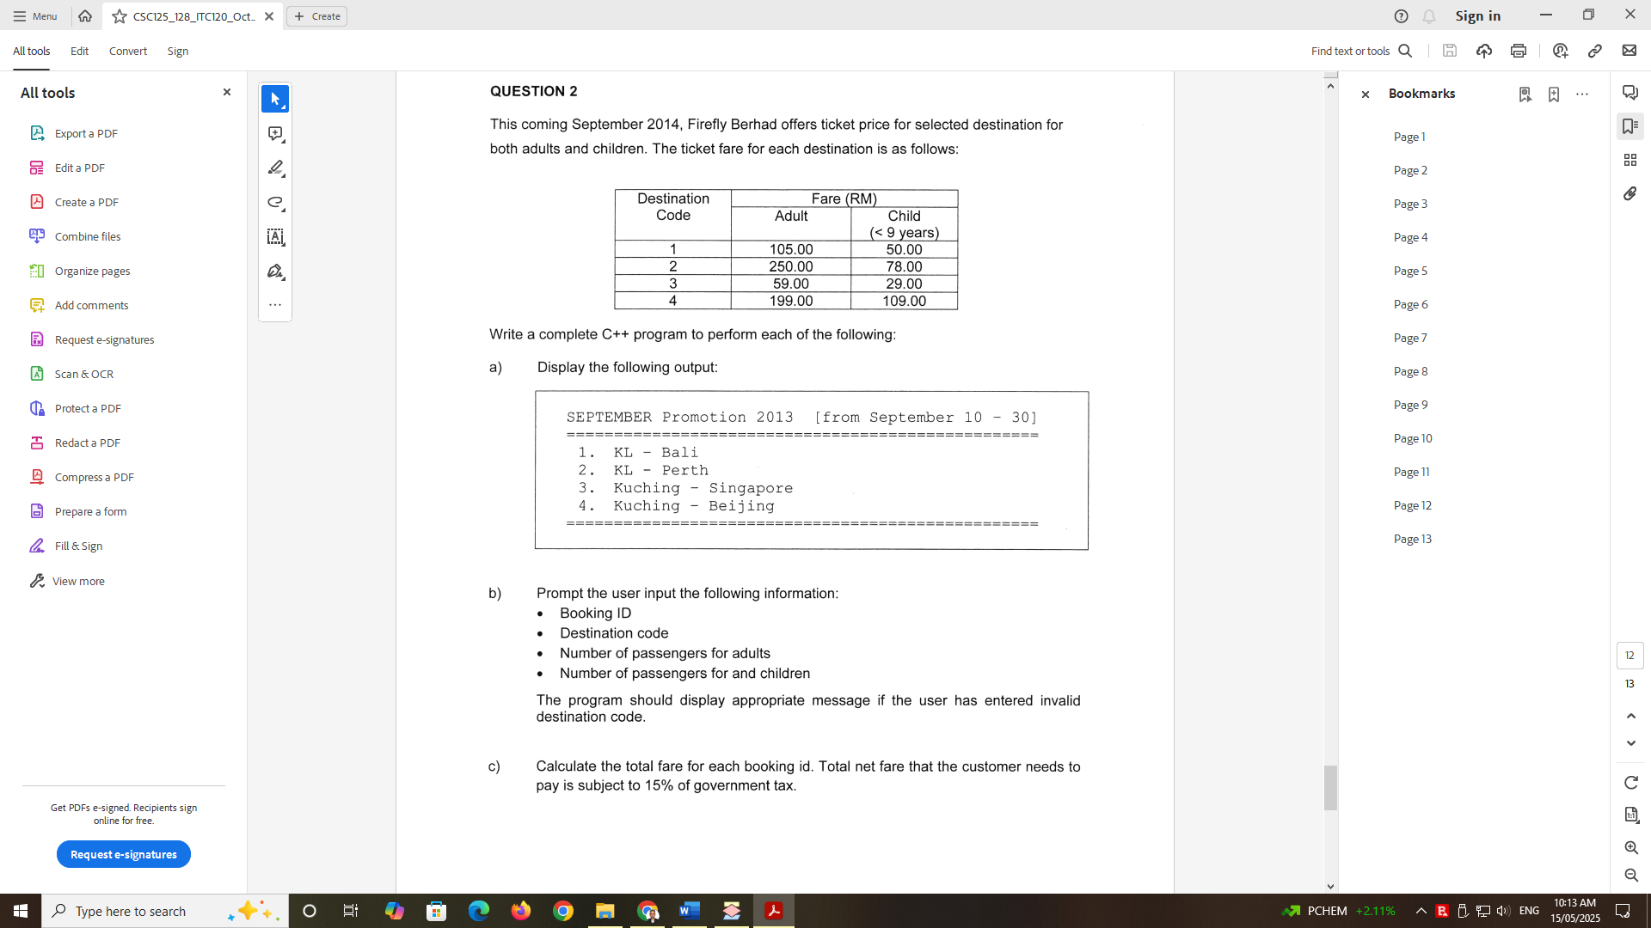



d)

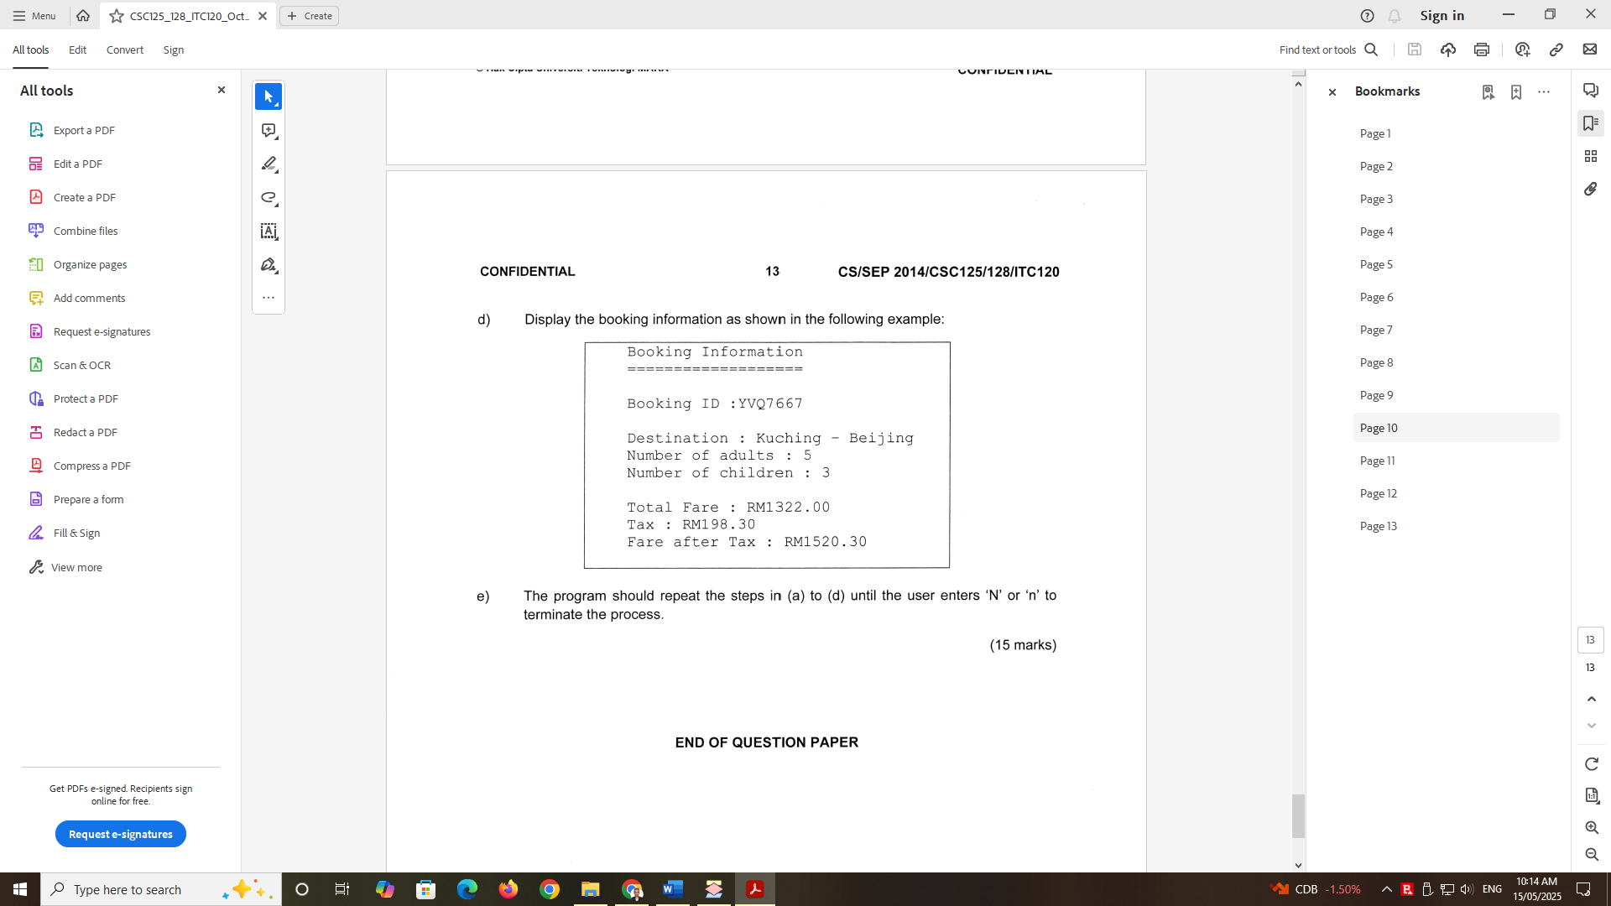



IPO

Flowchart

Pseudocode

Sample of output (Give 3 samples of ouput)

**Exercise 2:**

As a programmer in telecommunication company Maxcom Sdn Bhd, you are assigned to write a computer program to be used by the company. The program has to calculate charge for a customer’s usage of phone calls. The program should request the customer’s name, id, plan and the length of time (in minutes) used by a customer. The 15% discount will be given to a customer if the total amount of charge is more than RM100 for any plan.

|  |  |  |
| --- | --- | --- |
| **Plan** | **Less than or equal 100 minutes** | **Greater than 100 minutes** |
| **A** | RM 0.24 per minute | RM 0.15 per minute |
| **B** | RM 0.17 per minute | RM 0.25 per minute |

Display the details of a customer and the total amount of charge.

IPO

Flowchart

Pseudocode

Sample of output (Give 3 samples of ouput)